# 2. Linked List

A linked list consists of a series of nodes, each containing two main components: the data or value that the node holds and a reference (or pointer) to the next node in the sequence. It can does,’t have a fixed length (nodes can be dynamically allocated). The first node of the linked list is called the "head."

* Insertion is easier, more efficient
* Has to store pointers, though

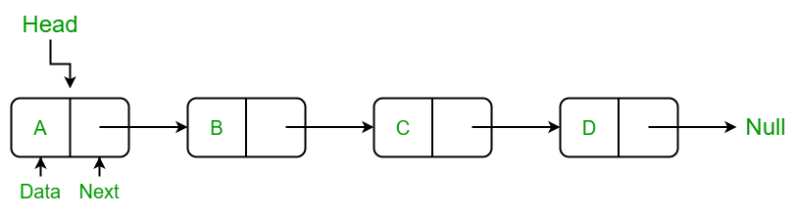

#### Complexity

* Insertion/ Deletion at head: O(1)
* Insertion/ Deletion: O(n)
* Traversal: O(n)
* Access element by value/index [search]: O(n)

**Doubly linked list:** Links to next and previous elements.

**Circular Linked Lists**: They do not have ends.

# POINTS

* Finding middle – by fast and slow pointers